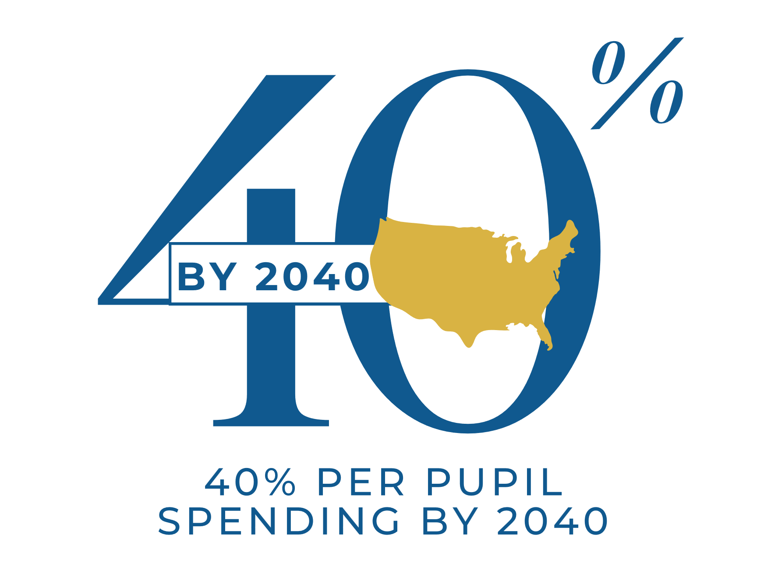
Sample Resolution in Support of 40 By 40: Fulfill the IDEA Promise
Please help urge Congress to fulfill its longstanding commitment to fund 40% of special education costs under IDEA by placing the below resolution on the agenda for action at a public meeting of your board of education November of 2026 through February/ of 2027.

Resolution Urging Congress to Fulfill Its Promise to
Fund 40 Percent of IDEA Costs
RESOLUTION NO. ____
A Resolution of the [Insert School District Name] School Board Urging the United States Congress to Fulfill Its Longstanding Commitment to Fund 40 Percent of Special Education Costs Under the Individuals with Disabilities Education Act (IDEA)
WHEREAS, the Individuals with Disabilities Education Act (IDEA) was enacted in 1975 to ensure that students with disabilities receive a Free Appropriate Public Education (FAPE); and
WHEREAS, Congress made a clear commitment in IDEA to fund 40 percent of the cost to educate students to help cover the excess costs of providing special education services; and
WHEREAS, despite this longstanding promise, federal IDEA funding has consistently fallen far short — in 2027 providing just 10 percent of the cost nationally — leaving the State of Illinois, local school districts, and taxpayers to subsidize the federal government’s unmet obligation; and
WHEREAS, students covered by IDEA have grown exponentially from 3.7 million in 1975 to 8.3 million students today; and
WHEREAS, statewide Illinois school districts collectively face a statewide special education shortfall exceeding $1.4 billion annually, requiring local districts to redirect general education revenues to meet mandated special education needs; and
WHEREAS, the federal funding shortfall places significant and increasing pressure on local budgets, widens funding imbalances among school districts, undermines general education programs, and forces reductions in staffing, class size initiatives, mental health supports, and other essential student services; and
WHEREAS, fulfilling the federal promise of 40 percent IDEA funding would provide substantial relief to Illinois school districts, reduce reliance on local levies, stabilize district budgets, and strengthen educational outcomes for all students;

NOW, THEREFORE, BE IT RESOLVED that the School Board of [Insert School District Name] hereby urges the United States Congress to:
1. Fulfill its statutory commitment to fund 40 percent of IDEA special education costs by supporting annual increases that result in 40 percent by the year 2040;
2. Ensure IDEA funding remains stable and protected from across-the-board cuts.
3. Publicly reaffirm the federal government’s responsibility to fully fund (40%) mandated special education services.

BE IT FURTHER RESOLVED, that the Board President and Superintendent are directed to share this resolution with:
  - The Members of the Illinois Congressional delegation representing the school district;
  - The Illinois Association of School Boards; and
  - The State legislators representing the school district.

ADOPTED by the School Board of [Insert School District Name] on this ___ day of ________, 2026 (or 2027).

Attested by: ________________________________, Board President
Attested by: ________________________________, Board Secretary

